

Suspension Analysis

Quality Control Procedure

Purpose

The purpose of this quality control procedure is to outline the steps to determine the quality attributes and yield of the manufactured suspension C.SLQ001.

Scope

This procedure is applies to the final quality control step of Silq’s Suspension manufactured at Silq’s manufacturing facility.

Documents

Reference Documents

MP-C.SLQ001 Manufacturing Procedure, Suspension Processing

SP-C.SLQ001 Specification, Suspension

QM.SLQ049 Workstation Practices SOP

Associated Documents / Forms

TR-C.SLQ001 Suspension Processing Traveler

TMP1-QC-C.SLQ001 Template, Suspension Quality Control Report

TMP2-QC-C.SLQ001 Template, Certificate of Analysis, Suspension

Definitions

Abbreviations / Acronyms

COA – Certificate of Analysis

DHR – Device History Record

F – Fluorine

H – Hydrogen

mL – Milliliter

NMR – Nuclear Magnetic Resonance

pH – Potential Hydrogen

ppm – Parts per Million

QA – Quality Assurance

TFE – Trifluoroethanol

General Definitions

N/A

Responsibilities

It is the responsibility of Manufacturing/Operations management or their authorized representative to ensure this procedure is adequate and appropriate for fulfilling the purpose of this document.

It is the responsibility of Silq personnel and approved contractor personnel to perform their job duties in compliance with the requirements of this procedure and its associated procedures, as appropriate, including ensuring that any output documentation from this procedure is complete and accurate.

Safety Information

Gloves (latex or nitrile) and safety eye wear are to be worn at all times during the execution of this procedure.

Equipment / Tools / Fixtures

Weighing scale (E.SLQ013)

Components / Materials / Supplies

High purity water (S.SLQ001)

Centrifuge tube, 50 mL, Polypropylene, Flat Cap (S.SLQ002)

Container, 8.5” x 18” x 6” (S.SLQ003)

Syringe, 10mL (S.SLQ004)

pH Strip (S.SLQ005)

Deuterium oxide (S.SLQ006)

Permanent pen

Procedure: Line Clearance

Perform line clearance of the work area in accordance with Workstation Practices QM.SLQ049.

Procedure: General Requirements

This quality control procedure will be performed and the results of the procedure shall be documented using the Suspension Quality Control Report template TMP1-QC-C.SLQ001.

Results of the quality control test shall be documented on the Certificate of Analysis template TMP2-QC-C.SLQ001 and will determine if the batch/lot of Suspension manufactured meets established acceptance criteria.

Procedure: Sample Preparation

Obtain the Suspension samples in the three (3) 50mL centrifuge tubes labeled Aliquot A, Aliquot B, and Aliquot C.

Label six (6) empty 50mL centrifuge tubes (S.SLQ002): Sample A1, Sample A2, Sample B1, Sample B2, Sample C1, and Sample C2.

Weigh the empty tubes and record the weight of the tubes on the Suspension Quality Control Report.

From each Aliquot tube, extract two (2) 10mL aliquots using a 10mL syringe and place each 10mL aliquot in their respective sample tubes. For example, two (2) 10mL aliquots from Aliquot A suspension sample tube will go into Sample A1 tube and Sample A2 tube, respectively. Do the same for Aliquot B and Aliquot C suspension samples.

The remaining contents of each Suspension sample tube (Aliquot A, Aliquot B, and Aliquot C) will be stored in reserve if further analysis is needed.

Freeze dry the sample tubes. After freeze drying, weigh each sample tube and record the weight (‘Weight with Residue’) in the Suspension Quality Control Report.

Using the aliquot volume of 10mL (0.01L), calculate the Suspension Sample Concentration for each tube and record in the Suspension Quality Control Report.

Calculate the Average Suspension Sample Concentration by calculating the average Suspension Sample Concentration from each tube and record in the Suspension Quality Control Report and the Suspension Processing Traveler.

Weigh an empty 50mL tube using the weighing scale (E.SLQ013) and label it ‘Suspension Test Sample.’ Record empty weight in the Suspension Quality Control Report. The dried contents of sample tubes A1, B1, and C1 will be combined into the ‘Suspension Test Sample’ tube and then resuspended with High Purity Water (S.SLQ001) to a concentration of 1% w/v and subject to analysis of Appearance (color), Appearance (form), Residue on Evaporation, Specific Gravity, and pH.

11.7 The dried contents of sample tubes A2, B2, and C2 will be combined into a separate 50mL centrifuge tube labeled ‘NMR Test Sample’ and then resuspended in 5mL of deuterium oxide (D2O) (S.SLQ006). A Bruker AV400 broad band FT NMR Spectrometer is used to obtain ¹H and ¹⁹F NMR Spectra. The Spectrometer is managed by the UCLA Molecular Instrumentation Center (MIC), a state-of-the-art campus-wide facility dedicated to enabling the use of modern instrumentation in molecular characterizations (www.mic.ucla.edu). The MIC is housed within and managed through the UCLA Department of Chemistry and Biochemistry. The professional staff consists of seven Ph.D. level staff members and graduate student assistants. The staff is responsible for operating, maintaining, and upgrading the equipment, training users, and providing consultation for the application of modern instrumentation.

Quality Control Test Procedure

Appearance

Visually inspect the Suspension test sample for color appearance. Record result in the Suspension Quality Control Report.

Acceptance criteria:

Color: Opaque white

Form: Inviscid liquid

Residue on Evaporation

Obtain a 50mL tube and label it ‘Residue on Evaporation Sample’.

Weigh the empty 50mL tube and record the weight in the Suspension Quality Control Report.

Obtain a 10mL aliquot from the Suspension Test Sample tube using a 10mL syringe and place into the ‘Residue on Evaporation Sample’ tube. Weight the ‘Residue on Evaporation Sample’ tube and record value.

Freeze dry the ‘Residue on Evaporation Sample’ tube for 48 hours so that all water is removed from the tube.

Weigh the ‘Residue on Evaporation Sample’ tube and record the weight (‘Weight with Residue on Evaporation’) in the Suspension Quality Control Report. Calculate the Residue on Evaporation %.

Residue on Evaporation % = (fill in)

Acceptance criteria:

Residue on Evaporation: 0.5% – 1.5%

pH

Fully insert a pH strip (S.SLQ005) into the Suspension test sample tube for 5 seconds and remove it. Allow the test strip to dry for 10 seconds.

Match the resulting color of the test strip to a pH level using the provided key. Record the pH value in the Suspension Quality Control Report.

Acceptance criteria:

5 – 8

¹H NMR

Obtain the ¹H NMR spectra of ‘NMR Test Sample’ prepared in Section 11.7. .

Attach the spectra to the Suspension Quality Control Report.

Acceptance criteria

A successful result is one that includes broad peaks within 0.2ppm of 0.99, 2.2, 2.9, 3.1, 3.5, 3.7, 4.4, and 4.75 ppm indicating successful incorporation of the zwitterion moiety into the polymer. The peak at 4.75 ppm is the ‘solvent peak’ resulting from the deuterium oxide solvent. All peaks should be easily identifiable and have an amplitude of at least 5% of the solvent peak. An acceptable ¹H NMR spectra plot is shown in Appendix A.

¹⁹F NMR

Obtain the ¹⁹F NMR spectra of ‘NMR Test Sample’ prepared in Section 11.7.

Attach the spectra to the Suspension Quality Control Report.

Acceptance criteria

A successful result is one that includes broad peaks within 5ppm of -140 and -150ppm indicating successful incorporation of the PFPA moiety into the polymer. These peaks should be broad with a small amplitude but still easily identifiable. If TFE is present in the polymer due to an incomplete diafiltration process during manufacturing, a large, sharp peak will also appear at -76ppm. If this peak is greater than 4X the amplitude of the peaks at -140 and -150ppm then the diafiltration process may be extended until a successful ¹⁹F NMR spectra is obtained. An acceptable ¹⁹F NMR spectra plot is shown in Appendix B. An unacceptable ¹⁹F NMR spectra plot is shown in Appendix C.

Sign and date the completed Suspension Quality Control Report and include the report in the batch DHR.

Procedure: Certificate of Analysis

Create a certificate of analysis using the COA template TMP2-QC-C.SLQ001.

Enter the test results for the applicable attributes based on the recorded results in the Suspension Quality Control Report.

Print out the COA. Sign and date the COA.

Attach a copy of the test results and COA to the batch DHR.

Include the original, signed COA with the product tank.

Appendix A: ¹H NMR Spectra (Acceptable)

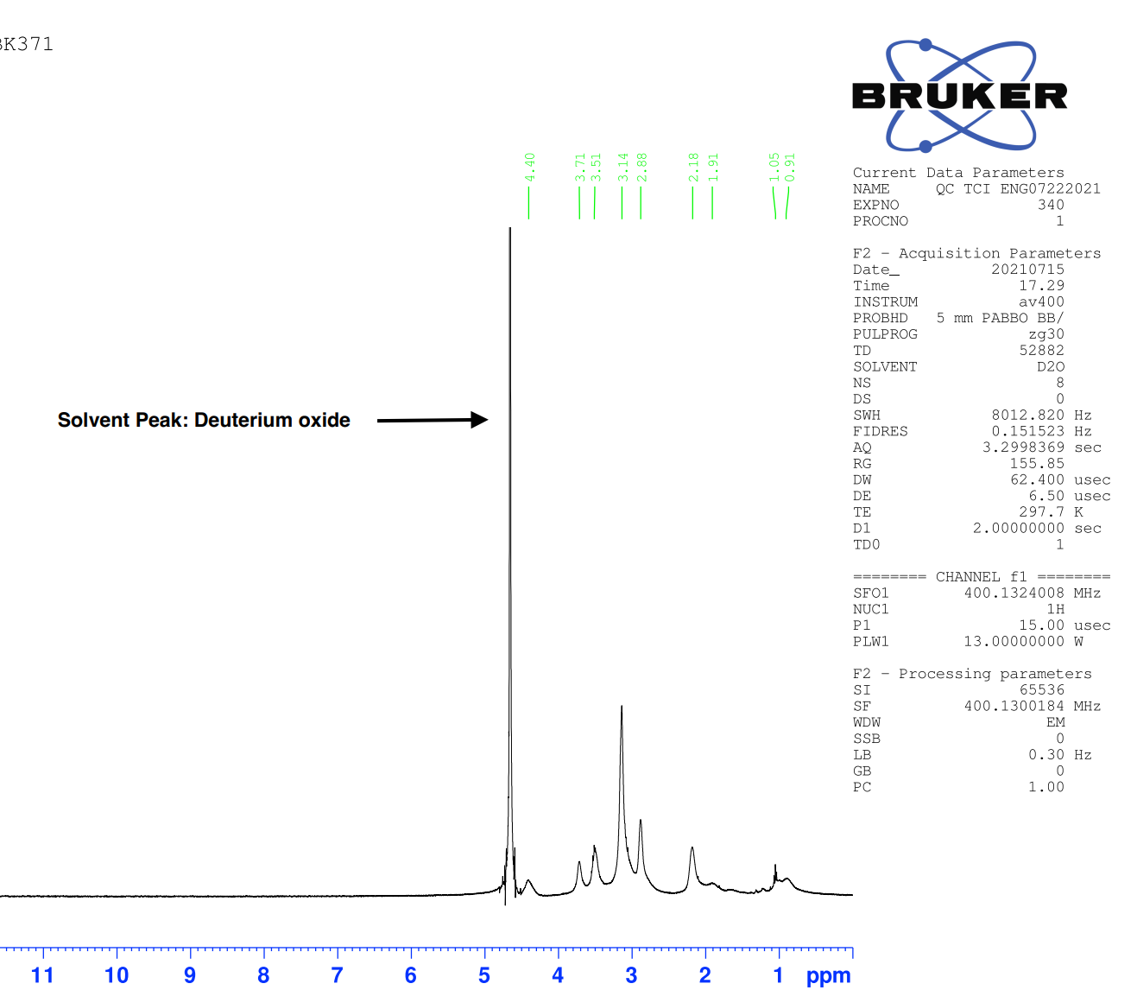

Appendix B: ¹⁹F NMR Spectra (Acceptable)

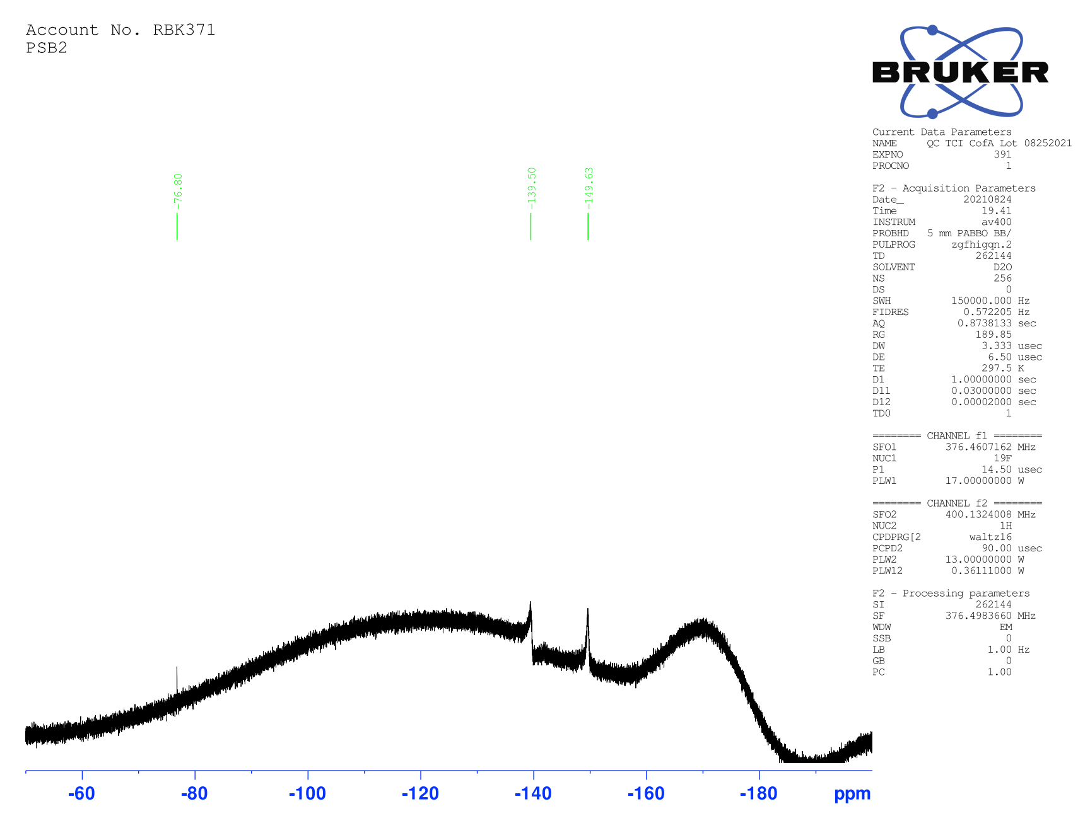

Appendix C: ¹⁹F NMR Spectra (Not Acceptable)

